SRS document

Contents

1. Introduction

1.1 Purpose of this document

1.2 Scope of this document

1.3 Overview

2. General Description

2.1 Product Functions

2.2 User Characteristics

2.3 User Problem Statement

2.4 User Objectives

2.5 General Constraints

3. Functional Requirements

4. Interface Requirements and User Interfaces

4.1 User Interfaces

4.2 Hardware Interface

4.3 Communications Interfaces

4.4 Software Interfaces

5. Performance Requirements

6. Other non-functional attributes

7. Operational Scenarios & screen shots

8. Preliminary Use Case Models and Sequence Diagrams

8.1 Use Case Model

9. Appendices, Team Details & link to GitHub repo

9.1 Definitions, Acronyms, Abbreviations

9.2 References

9.3 Team Details

1. Introduction

1.1 Purpose of this document

To give detailed specifications on the “News Aggregator App 1.0” which will combine the use of Django, React.js and Web scrapping and also the team’s knowledge on Database Systems.

1.2 Scope of this document

The main focus of this product is to source a full fledged website which aggregates news from a list of selected websites and is delivered to the user using the site for the purpose of reading news on the go**, reading latest & trending news from top news sources such as TOI, HT, BTC, NDTV etc.**

1.3 Overview

We read newspapers daily, we also see some news in different websites all the time. Similarly we don’t have time to read the whole newspaper, nor the time to browse every website that provides news. To make this easier we are trying to build a web application that aggregates news from different websites in one place. Our news aggregator make this task easier by bringing all the news from different websites into one place. You will be just one click away from **reading the latest and trending news**. News Aggregator service is an important for the start of the day.

2. General Description

2.1 Product Functions

The proposed idea will be able maintain the headlines of the news from various websites and embedded photos of that particular website. Certain users should be able to log on to update information and documents available to the general public. Any user visiting the site shall be able to use every feature mentioned providing their computer has the proper software and/or hardware.

2.2 User Characteristics

The new content of the news will be incorporated into the web app that our team is working on creating. The user will need to have some expertise in using dropdown menus, slideshows, radio buttons, checkboxes and scrolling the screen.

2.3 User Problem Statement

News information is poorly organized and spread out on different websites having various types of headlines. Shortage of time to a working person in the modern world to read newspapers and scroll through numerous news applications.

2.4 User Objectives

**The user will have the latest news from top news sources like Hindustan Times(HT) , NDTV, BTC, TOI etc**. A log on shall be placed on the app. Users will have their own private account so that they can access their desired news sources any time of the day and also an **added functionality of viewing the weather for that particular day**. The administrators that have properly logged in shall be able to update and add and/or remove selected news sources based on licensing.

2.5 General Constraints

* The project must be completed within the time-constraints of this semester
* The project must be completed using Django and React.js and any other python libraries

3. FUnctional Requirements

1. System should allow the administrator to log in
2. System should allow the user to log in
3. System should allow the administrator to log out
4. System should allow users to log out
5. System shall allow the admin to update the list of news sources for the user
6. **System shall have an ordered feed of headlines on the main page, along with the source**
7. **System shall allow the admin to change the choice of websites from where the news is brought onto the homepage.**
8. System shall allow the admin and the user to change the password

4. Interface requirements

4.1 User Interfaces

* GUI - The web interface for this web app will be customized by React.js
* CLI – There is no CLI’s required for the functionality we desire
* API – There is no API required for the functionality we desire
* Diagnostics or ROM – There are no Diagnostic’s or ROM’s user interfaces required for the functionality we desire

4.2 Hardware Interfaces

The users need to have access to a keyboard, monitor and a computer to view and manage our app. Users are highly recommended to have a mouse and speakers for full functionality.

4.3 Communications Interfaces

The users need to have access to unrestricted Internet via broadband, dial-up or wired

4.4 Software Interfaces

The users need to have a functional OS that includes up to date Internet browser with JavaScript enables, such as IE, Chrome, Firefox, Opera or Safari.

5. Performance requirements

Users should have a moderate computer with at least a 3G or 4G enabled Wi-Fi or modem for internet access.

6. Other non-functional attributes

* Security : The secure system shall be able to verify the administrator and officer’s username and password. In order to maintain correct information and features on the site, only the admin has full functionality to add, edit and manage the desired needs.
* Binary Compatibility : The system shall not require any local binary encoding OS to access the PHP server while loading the webpage.
* Reliability: The system should be accessible 24/7
* Maintainability : The system should be easily maintainable for the average admin and user.
* Portability: The system should allow users to access the site from any web browser on any mobile device/PC/Laptop

7. Operational scenarios & screen shots

1. Administrator log in
2. User Log in
3. Administrator Log out
4. User log out
5. Administrator update list of news sources
6. Administrator to change the homepage feed of news sources
7. Administrator and the user to change the password

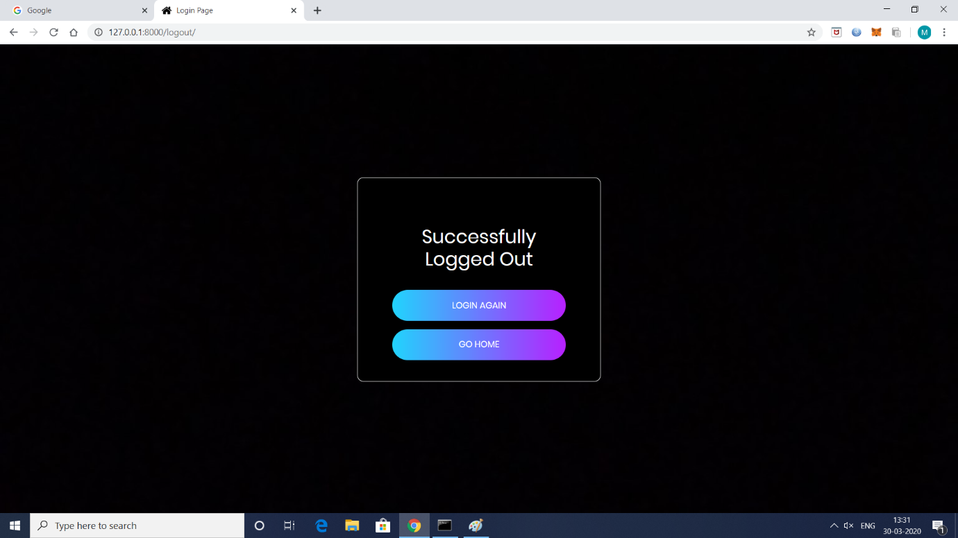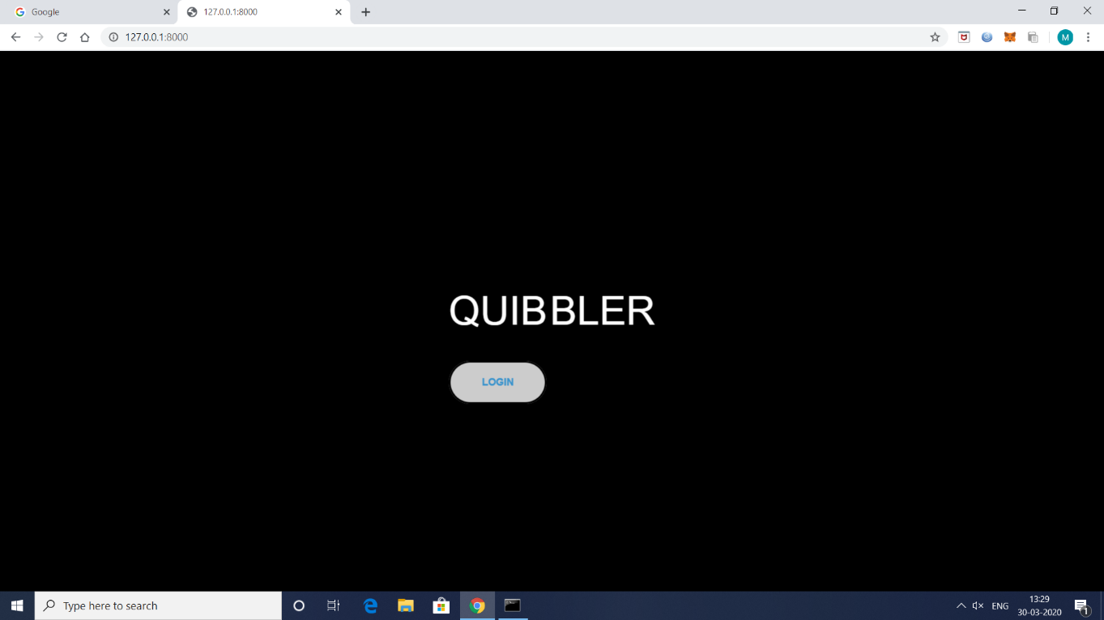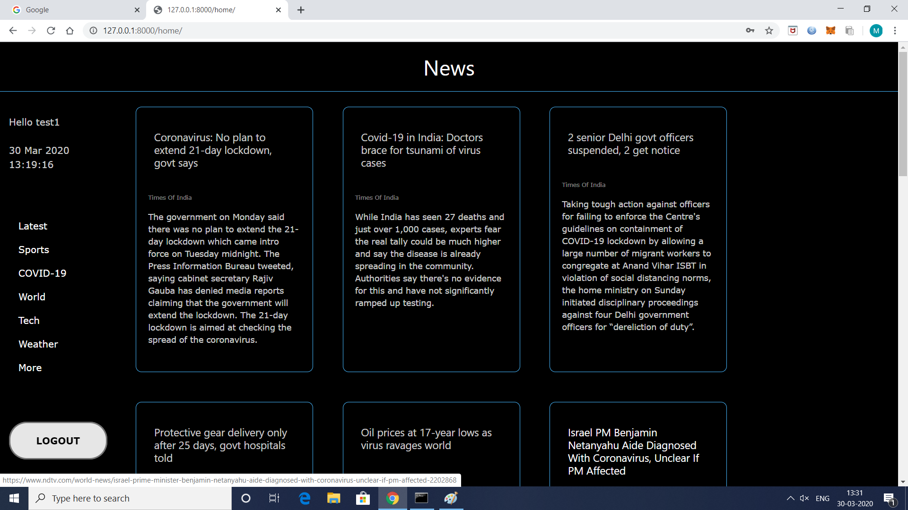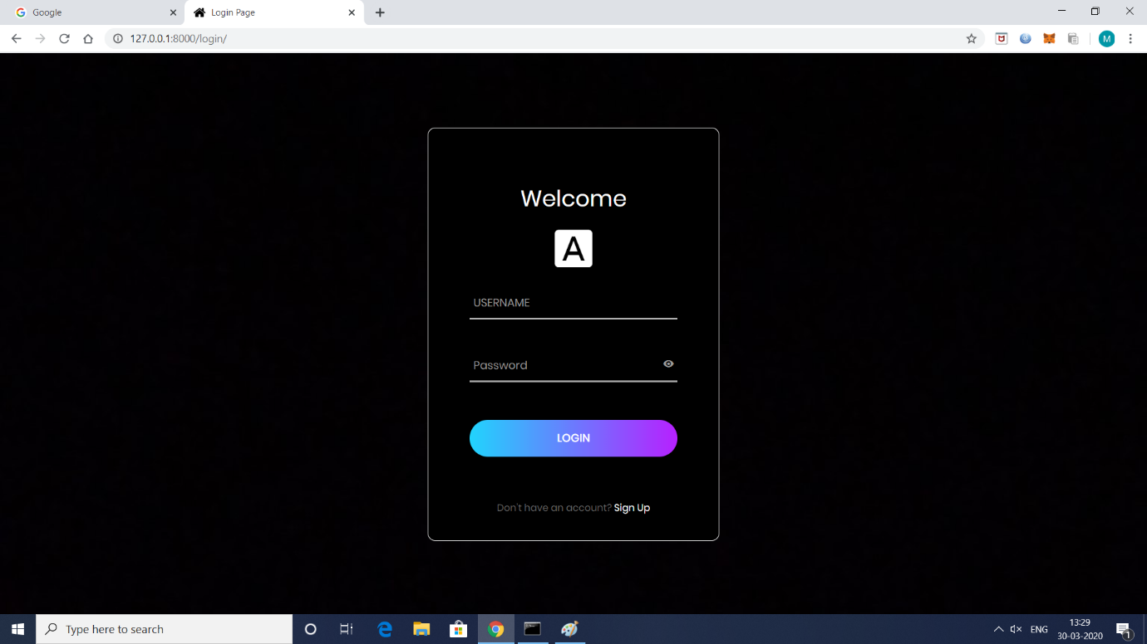

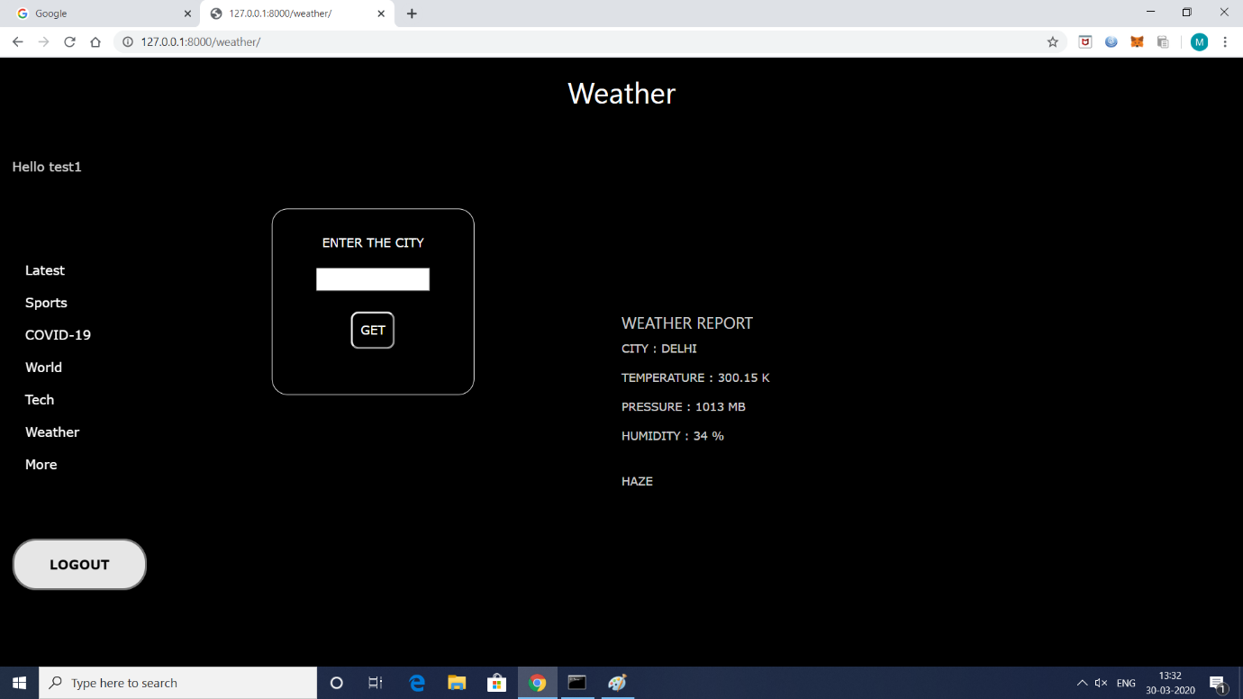

8. PRElimnary use case model

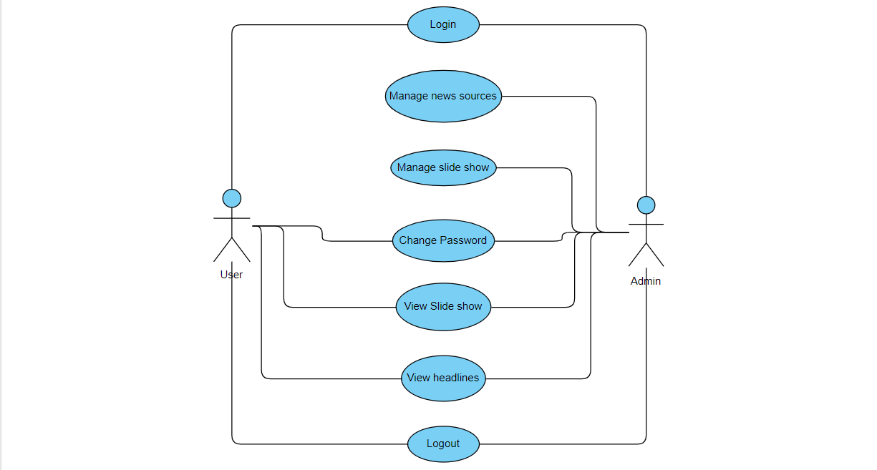

Manage slide show -> **Manage the news feed from various websites**

View slide show -> **View the news feed**

9. Appendices

9.1 Definitions, Acronyms, Abbreviations

* GUI – Graphical User Interface
* CLI – Command line Interface
* API – Application Programming Interface
* ROM – Read Only Memory
* PHP – Hypertext Pre-processor

9.2 References

* <https://online.visual-paradigm.com/drive/#diagramlist:proj=0&new=UseCaseDiagram>

9.3 Team Details

1. **Sakshi V**
2. **Srinath Kesav Nallamalli**
3. **Manjunath R.Hegde**
4. **Sameer Prasad Subhedar**

9.4 GitHub repository

Link : [**https://github.com/samsub18/News-Aggregator**](https://github.com/samsub18/News-Aggregator)